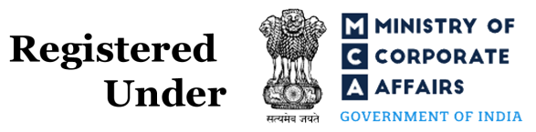
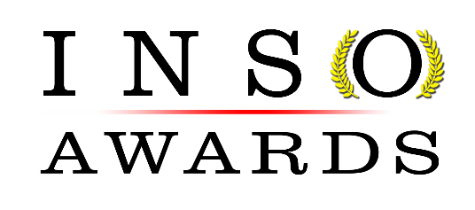

(Regd. Organization of the Indian Trust Act, 2013) Reg. no: U22190TN2019NPL127500

Application Form
International Eminent Awards on Engineering, Science and Medicine
(Online)

Part – I
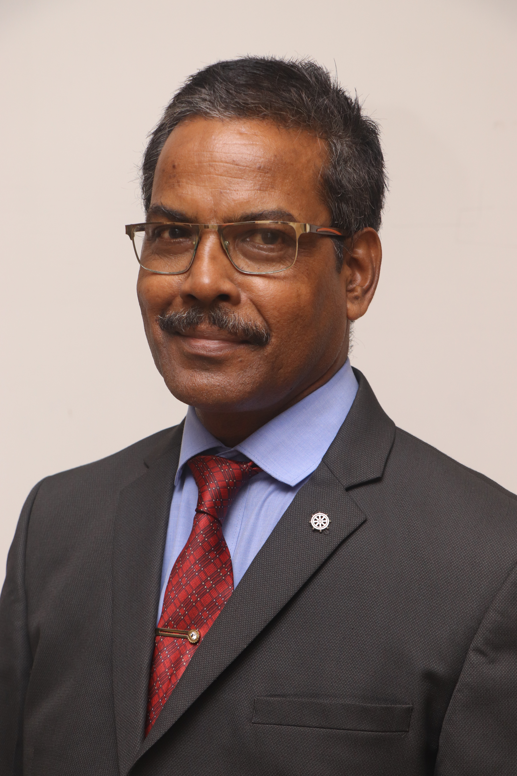
Paste Your Photo

Name of the Applicant |  |  |  |  | Gender
  Dr. Dilip Kr. Goswami
  Male
Date of Birth |  |  |  |  | Age
  2/1/1963
  59 years
Place of Birth |  |  |  |  | Nationality
  Guwahati
  Indian
Email Id |  |  |  |  | Citizenship
  drdilipgoswami37@gmail.com
  Indian
Mobile Number |  |  |  |  | Years of Experience
  9864351115
  25 years
Address
  Sundarbari , Jalukbari , P.O.- Gauhati University , Pin – 781014 , Dist. : - Kamrup (Metro) , Assam
Part - II Present Employment

Designation |  |  |  | Date of Joining in the Organization
  Associate Professor
  1/7/1997
 | Name of the Department / Division
  Agada Tantra and Vidhi Ayurveda (Toxicology and Forensic Medicine) (under Health and Family Welfare Dept. – Ayurveda )
 | Name & Address of the Organization
  Govt. Ayurvedic College , Jalukbari , Guwahati – 781014 , Assam

Part– III (Academics)
Degree | Specialization | Name of the University | Period
B.A.M.S (Ayurvedacharyya) | Ayurveda | Gauhati University , Assam , India | 1982-1989
MD (Ayurveda) | Kayachikitsa(Medicine) | Utkal University , Odisa ,India | 1999- 2002
Ph. D. | Ayurveda | Srimanta Sankaradeva University of Health Sciences , Assam , India | 2010 -2015
Part - V (Doctoral Degree details)
Department | Ayurveda | Laboratory
Name of PhD Supervisor | Prof. (Dr.) Rama Kanta Sharma
Title of PhD Thesis | Experimental study on efficacy of ‘Ghrita-Sita-Kshira Yoga’ in Dhatura (Dhatura metel Linn) poisoning on animals
Year of Completion of PhD | 2015

Part–VI (Mention Total Numbers Only)

Criteria | Status | No’s
Patents | Granted | Nil
Patents | Under Process | Nil
Consultancy Projects | Completed | Nil
Consultancy Projects | Sanctioned | Nil
SCI / SSCI Indexed Articles | Published | Nil
SCI / SSCI Indexed Articles | Accepted | Nil
SCOPUS Indexed Articles | Published | Nil
SCOPUS Indexed Articles | Accepted | Nil
Other Indexed Articles | Published | 51
Other Indexed Articles | Accepted | Nil
Countries Visited | For Study | Nil
Countries Visited | For Presentation | 2
Awards Received | International | 11
Awards Received | National | Nil

Criteria | Status | No’s
Papers Presented in Conferences | International | Nil
Papers Presented in Conferences | National | 38
Invited Presentations  Delivered | Scientific Meetings | Nil
Invited Presentations  Delivered | Workshops | 8
Invited Presentations  Delivered | Conferences | 4
Invited Presentations  Delivered | Seminars | Nil
Books Authored with ISBN | Books | 1
Books Authored with ISBN | Book Chapters | 4
Professional Membership | International | Nil
Professional Membership | National | 3
Editorial Appointments in Journals | Editor in Chief | Nil
Editorial Appointments in Journals | Associate Editor | Nil
Editorial Appointments in Journals | Board Member | 5
Editorial Appointments in Journals | Reviewer | 5

Part– VII (Please do not exceed 400 words per question)

About Yourself:
Completed B.A.M.S in 1989 from Gauhati University and joined as a faculty member at Govt. Ayurvedic College , Guwahati , Assam , India in 1997 . During the period 1989 to 1997 completed house physicianship and then engaged in private practice . In 1999 joined in MD (Ayurveda) course and completed in 2022 . Continuing with the service as faculty member at Govt. Ayurvedic College , Guwahati , Assam , India joined in Ph. D. course in 2010 and awarded with the Ph. D. degree from Srimanta Sankaradeva University of Health Sciences , Assam , India in 2015 . Now delivering service as Associate Professor at Govt. Ayurvedic College , Guwahati , Assam , India since 1997 is having interest and enthusiasm in exploring the hidden treasure on health science from the Ayurvedic classics and to publish in the journals , magazines etc. for appraisal and justification on the concepts of the ancient authors on health science “Ayurveda” . Attended a number of conferences/workshops/symposiums on Ayurvedic /Modern medical topics , presented papers , delivered lectures , published books and articles of different categories (review article , opinion, short communication , editorial etc.) . Now being associated with 5 indexed journals as member of editorial board and reviewer .
SPECIALLY INTERESTED – in exploring the principles and facts related to health in the Ayurvedic classics .

Part–VIII (Self Declaration)

I confirm that to the best of my knowledge, the information given in this form is correct and complete. At any time I am found to have concealed / distorted any material information, my application shall be liable to be summarily terminated without notice / compensation. I have read the terms and conditions and other policies of the International Scientist Awards and agree to abide the same. I agree to process the data submitted in this application form, or any other data that the Organization may obtain from me for any purposes connected with INSO or for any other legitimate reason.



Date : 29-09-2022 Place: Jalukbari, Guwahati, Assam Scanned Signature of Applicant

Note:
- The filled applications along with duly completed curriculum vitae (of any format), Pass port size photograph, Scan copy of the PhD Certificate & Scan copy of the Work place ID should be sent via email to: eminentawards2022@gmail.com

